SUPPORTING INFORMATION

Morphology of four common and phylogenetically distant ant species varies along disturbance and aridity gradients in the Caatinga dry forest

Fernanda M.P. Oliveira^{1,*}, Lucas Lima Silva², Inara R. Leal³ and Xavier Arnan^{1, 4}

¹Programa de Pós-Graduação em Biologia Vegetal, Universidade Federal de Pernambuco, Av. Prof. Moraes Rego, s/ no., 50670-901, Cidade Universitária, Recife, PE, Brazil
²Graduação em Ciências Biológicas com ênfase em Ciências Ambientais, Universidade Federal de Pernambuco, Av. Prof. Moraes Rego, s/ no., 50670-901, Cidade Universitária, Recife, PE, Brazil
³Departamento de Botânica, Universidade Federal de Pernambuco, Av. Prof. Moraes Rego, s/ no., 50670-901, Cidade Universitária, Recife, PE, Brazil
⁴Universidade de Pernambuco – Campus Garanhuns, Rua Capitão Pedro Rodrigues 105, 55294-902, Garanhuns, PE, Brazil

*Corresponding author: nandajovi@gmail.com

Table S1. Global multimeric disturbance index (GMDI), water deficit (WD), presence of ant species, and mean (M) and variance (V) of traits HBN, north-eastern Brazil. CL = ratio of clypeus length to mesosoma length, ML = ratio of mandible length to mesosoma length, WL = mesosoma or Weber’s length, IOW = ratio of inter-ocular width to mesosoma length, EL = ratio of eye length to mesosoma length, P = count of hairs crossing mesosoma profile, LEG = ratio of leg length (combined length of femur and tibia) to mesosoma length and AL = ratio of antenna (combined funicle and scape) length to mesosoma length.
Ant species | Plot | GMDI | DH | Traits
 |  |  |  | CL |  | ML |  | WL |  | IOW |  | EL |  | P |  | LEG |  | AL
 |  |  |  | M | V | M | V | M | V | M | V | M | V | M | V | M | V | M | V
Dinoponera  quadriceps | P02 | 52.868 | 952 | 0.261 | 0.00001 | 0.541 | 0.00003 | 8.933 | 0.00833 | 0.433 | 0.00014 | 0.164 | 0.00008 | 10.400 | 4.30000 | 1.739 | 0.00109 | 1.750 | 0.00134
Dinoponera  quadriceps | P07 | 21.958 | 1077 | 0.278 | 0.00002 | 0.562 | 0.00022 | 8.833 | 0.12963 | 0.430 | 0.00009 | 0.165 | 0.00002 | 10.250 | 4.91667 | 1.742 | 0.00203 | 1.709 | 0.00288
Dinoponera  quadriceps | P10 | 36.714 | 926 | 0.277 | 0.00004 | 0.562 | 0.00009 | 8.667 | 0.02778 | 0.442 | 0.00009 | 0.161 | 0.00006 | 9.800 | 6.70000 | 1.758 | 0.00033 | 1.743 | 0.00065
Dinoponera  quadriceps | P11 | 48.271 | 929 | 0.280 | 0.00005 | 0.573 | 0.00002 | 8.722 | 0.06481 | 0.446 | 0.00026 | 0.159 | 0.00004 | 9.000 | 3.00000 | 1.745 | 0.00030 | 1.726 | 0.00002
Dinoponera  quadriceps | P14 | 11.008 | 1051 | 0.277 | 0.00005 | 0.572 | 0.00003 | 8.833 | 0.02778 | 0.453 | 0.00007 | 0.163 | 0.00007 | 9.333 | 4.33333 | 1.786 | 0.00006 | 1.761 | 0.00006
Dinoponera  quadriceps | P15 | 20.379 | 1086 | 0.289 | 0.00010 | 0.563 | 0.00014 | 8.533 | 0.07500 | 0.438 | 0.00009 | 0.156 | 0.00002 | 12.400 | 20.80000 | 1.770 | 0.00229 | 1.801 | 0.00185
Dinoponera  quadriceps | P17 | 2.743 | 658 | 0.255 | 0.00001 | 0.531 | 0.00003 | 9.033 | 0.04722 | 0.439 | 0.00002 | 0.151 | 0.00009 | 12.400 | 36.30000 | 1.753 | 0.00099 | 1.750 | 0.00065
Dinoponera  quadriceps | P20 | 9.071 | 931 | 0.269 | 0.00004 | 0.550 | 0.00026 | 8.667 | 0.04167 | 0.435 | 0.00014 | 0.154 | 0.00001 | 15.200 | 11.20000 | 1.746 | 0.00054 | 1.766 | 0.00099
Dinoponera  quadriceps | P21 | 22.438 | 734 | 0.266 | 0.00001 | 0.566 | 0.00013 | 8.900 | 0.06389 | 0.446 | 0.00014 | 0.146 | 0.00008 | 9.600 | 2.30000 | 1.746 | 0.00031 | 1.727 | 03.
Dinoponera  quadriceps | P23 | 45.766 | 802 | 0.267 | 0.00012 | 0.565 | 0.00001 | 8.944 | 0.14815 | 0.435 | 0.00001 | 0.155 | 0.00023 | 9.667 | 2.33333 | 1.720 | 0.00048 | 1.722 | 0.00324
Dinoponera  quadriceps | P26 | 31.253 | 947 | 0.281 | 0.00003 | 0.567 | 0.00034 | 8.750 | 0.17593 | 0.433 | 0.00001 | 0.162 | 0.00006 | 10.750 | 8.91667 | 1.739 | 0.00099 | 1.739 | 0.00154
Dinoponera  quadriceps | P27 | 26.845 | 664 | 0.259 | 0.00005 | 0.537 | 0.00020 | 9.000 | 0.05556 | 0.437 | 0.00001 | 0.156 | 0.00012 | 9.400 | 15.80000 | 1.741 | 0.00072 | 1.727 | 0.00172
Dinoponera  quadriceps | P29 | 26.161 | 833 | 0.272 | 0.00006 | 0.558 | 0.00017 | 8.600 | 0.06389 | 0.434 | 0.00005 | 0.155 | 0.00015 | 11.400 | 20.30000 | 1.753 | 0.00090 | 1.799 | 0.00190
Dinoponera  quadriceps | P30 | 58.066 | 667 | 0.281 | 0.00010 | 0.558 | 0.00020 | 8.667 | 0.08333 | 0.427 | 0.00004 | 0.154 | 0.00002 | 13.200 | 10.70000 | 1.709 | 0.00325 | 1.766 | 0.00158
Ectatomma  muticum | P02 | 52.868 | 952 | 0.164 | 0.00003 | 0.430 | 0.00006 | 3.413 | 0.02533 | 0.465 | 0.00032 | 0.171 | 0.00019 | 3.200 | 0.20000 | 1.488 | 0.00105 | 1.435 | 0.00202
Ectatomma  muticum | P04 | 22.316 | 994 | 0.224 | 0.00001 | 0.429 | 0.00017 | 3.480 | 0.02089 | 0.463 | 0.00003 | 0.147 | 0.00003 | 2.600 | 0.80000 | 1.495 | 0.00154 | 1.450 | 0.00210
Ectatomma  muticum | P07 | 21.958 | 1077 | 0.227 | 0.00020 | 0.435 | 0.00066 | 3.280 | 0.13200 | 0.463 | 0.00009 | 0.137 | 0.00009 | 2.800 | 0.70000 | 1.535 | 0.00101 | 1.470
Ectatomma  muticum | P10 | 36.714 | 926 | 0.222 | 0.00001 | 0.428 | 0.00002 | 3.427 | 0.00578 | 0.443 | 0.00005 | 0.140 | 0.00001 | 2.200 | 0.20000 | 1.514 | 0.00072 | 1.444 | 0.00049
Ectatomma  muticum | P11 | 48.271 | 929 | 0.198 | 0.00009 | 0.439 | 0.00012 | 3.480 | 0.04533 | 0.465 | 0.00014 | 0.154 | 0.00003 | 1.600 | 0.30000 | 1.481 | 0.00206 | 1.454 | 0.00262
Ectatomma  muticum | P14 | 11.008 | 1051 | 0.246 | 0.00021 | 0.429 | 0.00007 | 3.120 | 0.01422 | 0.446 | 0.00003 | 0.143 | 0.00004 | 2.000 | 0.50000 | 1.517 | 0.00096 | 1.531 | 0.00340
Ectatomma  muticum | P16 | 36.371 | 1051 | 0.198 | 0.00004 | 0.451 | 0.00032 | 3.440 | 0.03022 | 0.485 | 0.00032 | 0.158 | 0.00012 | 1.800 | 0.20000 | 1.514 | 0.00304 | 1.484 | 0.00165
Ectatomma  muticum | P17 | 2.743 | 658 | 0.165 | 0.00003 | 0.441 | 0.00012 | 3.360 | 0.03689 | 0.461 | 0.00004 | 0.147 | 0.00014 | 3.200 | 1.70000 | 1.504 | 0.00013 | 1.476 | 0.00023
Ectatomma  muticum | P23 | 45.766 | 802 | 0.212 | 0.00007 | 0.438 | 0.00010 | 3.333 | 0.02667 | 0.462 | 0.00006 | 0.151 | 0.00008 | 3.000 | 0.50000 | 1.477 | 0.00067 | 1.450 | 0.00253
Ectatomma  muticum | P25 | 19.231 | 1003 | 0.207 | 0.00002 | 0.441 | 0.00036 | 3.453 | 0.02756 | 0.455 | 0.00045 | 0.160 | 0.00003 | 3.400 | 1.80000 | 1.476 | 0.00137 | 1.461 | 0.00293
Ectatomma  muticum | P26 | 31.253 | 947 | 0.233 | 0.00036 | 0.436 | 0.00050 | 3.127 | 0.37081 | 0.458 | 0.00025 | 0.151 | 0.00008 | 2.200 | 1.06667 | 1.509 | 0.00293 | 1.520 | 0.00945
Ectatomma  muticum | P27 | 26.845 | 664 | 0.192 | 0.00003 | 0.432 | 0.00035 | 3.613 | 0.02311 | 0.473 | 0.00025 | 0.157 | 0.00005 | 2.200 | 1.20000 | 1.496 | 0.00260 | 1.430 | 0.00313
Ectatomma  muticum | P29 | 26.161 | 833 | 0.221 | 0.00012 | 0.425 | 0.00029 | 3.373 | 0.02133 | 0.457 | 0.00029 | 0.147 | 0.00004 | 3.200 | 0.20000 | 1.471 | 0.00315 | 1.468 | 0.00184
Pheidole  radoskowiskii | P02 | 52.868 | 952 | 0.165 | 0.00007 | 0.425 | 0.00160 | 0.847 | 0.00256 | 0.598 | 0.00008 | 0.181 | 0.00034 | 1.600 | 1.30000 | 1.669 | 0.00190 | 2.240 | 0.00859
Pheidole  radoskowiskii | P04 | 22.316 | 994 | 0.184 | 0.00028 | 0.448 | 0.00009 | 0.833 | 0.00167 | 0.608 | 0.00088 | 0.176 | 0.00027 | 3.200 | 0.70000 | 1.711 | 0.00306 | 2.258 | 0
Pheidole  radoskowiskii | P08 | 16.876 | 1014 | 0.185 | 0.00005 | 0.430 | 0.00008 | 0.900 | 0.00111 | 0.622 | 0.00046 | 0.185 | 0.00005 | 0.600 | 0.80000 | 1.712 | 0.00168 | 2.119 | 0.00536
Pheidole  radoskowiskii | P15 | 20.379 | 1086 | 0.197 | 0.00037 | 0.467 | 0.00012 | 0.813 | 0.00144 | 0.574 | 0.00064 | 0.197 | 0.00021 | 1.600 | 0.80000 | 1.713 | 0.00080 | 2.281 | 0.00436
Pheidole  radoskowiskii | P16 | 36.371 | 1051 | 0.186 | 0.00015 | 0.435 | 0.00039 | 0.860 | 0.00189 | 0.605 | 0.00021 | 0.186 | 0.00030 | 1.400 | 0.30000 | 1.658 | 0.00109 | 2.173 | 3
Pheidole  radoskowiskii | P20 | 9.071 | 931 | 0.172 | 0.00038 | 0.425 | 0.00018 | 0.893 | 0.00078 | 0.604 | 0.00094 | 0.187 | 0.00003 | 2.000 | 0.50000 | 1.701 | 0.00263 | 2.172 | 0.00048
Pheidole  radoskowiskii | P21 | 22.438 | 734 | 0.190 | 0.00004 | 0.424 | 0.00031 | 0.880 | 0.00089 | 0.606 | 0.00073 | 0.190 | 0.00004 | 2.200 | 0.70000 | 1.743 | 0.00407 | 2.190 | 0.00686
Pheidole  radoskowiskii | P22 | 9.146 | 1037 | 0.183 | 0.00031 | 0.450 | 0.00011 | 0.873 | 0.00078 | 0.595 | 0.00019 | 0.176 | 0.00041 | 1.800 | 0.70000 | 1.718 | 0.00075 | 2.199 | 0.00226
Pheidole  radoskowiskii | P23 | 45.766 | 802 | 0.184 | 0.00020 | 0.439 | 0.00092 | 0.867 | 0.00056 | 0.624 | 0.00109 | 0.192 | 0.00003 | 3.200 | 1.20000 | 1.762 | 0.00140 | 2.247 | 0.00328
Pheidole  radoskowiskii | P25 | 19.231 | 1003 | 0.182 | 0.00024 | 0.463 | 0.00028 | 0.807 | 0.00300 | 0.570 | 0.00128 | 0.174 | 0.00020 | 1.400 | 0.80000 | 1.704 | 0.00397 | 2.250 | 0.00495
Pheidole  radoskowiskii | P27 | 26.845 | 664 | 0.184 | 0.00003 | 0.434 | 0.00067 | 0.907 | 0.00078 | 0.625 | 0.00019 | 0.184 | 0.00003 | 3.000 | 0.50000 | 1.773 | 0.00573 | 2.222 | 0.00278
Pheidole  radoskowiskii | P28 | 26.606 | 789 | 0.192 | 0.00003 | 0.431 | 0.00042 | 0.867 | 0.00056 | 0.616 | 0.00102 | 0.192 | 0.00003 | 3.200 | 1.70000 | 1.739 | 0.00203 | 2.256 | 0.01141
Pheidole  radoskowiskii | P30 | 58.066 | 667 | 0.180 | 0.00028 | 0.429 | 0.00060 | 0.853 | 0.00256 | 0.602 | 0.00121 | 0.188 | 0.00021 | 2.800 | 2.70000 | 1.805 | 0.00283 | 2.293 | 0.01444
Dorymyrmex  thoracicus | P04 | 22.316 | 994 | 0.153 | 0.00001 | 0.352 | 0.00070 | 1.307 | 0.00078 | 0.275 | 0.00038 | 0.163 | 0.00012 | 0.000 | 0.00000 | 1.893 | 0.00300 | 1.919 | 0.00108
Dorymyrmex  thoracicus | P07 | 21.958 | 1077 | 0.142 | 0.00002 | 0.355 | 0.00007 | 1.220 | 0.00422 | 0.273 | 0.00008 | 0.169 | 0.00001 | 0.000 | 0.00000 | 1.891 | 0.00255 | 1.983 | 0.01629
Dorymyrmex  thoracicus | P08 | 16.876 | 1014 | 0.133 | 0.00006 | 0.373 | 0.00052 | 1.253 | 0.00533 | 0.288 | 0.00014 | 0.176 | 0.00033 | 0.000 | 0.00000 | 1.923 | 0.00630 | 1.976 | 0.00419
Dorymyrmex  thoracicus | P10 | 36.714 | 926 | 0.139 | 0.00022 | 0.363 | 0.00057 | 1.193 | 0.00356 | 0.274 | 0.00023 | 0.173 | 0.00001 | 0.000 | 0.00000 | 1.831 | 0.00159 | 1.938 | 0.00264
Dorymyrmex  thoracicus | P14 | 11.008 | 1051 | 0.121 | 0.00002 | 0.359 | 0.00004 | 1.207 | 0.01411 | 0.271 | 0.00020 | 0.166 | 0.00015 | 0.000 | 0.00000 | 1.920 | 0.00187 | 2.056 | 0.01042
Dorymyrmex  thoracicus | P15 | 20.379 | 1086 | 0.130 | 0.00020 | 0.361 | 0.00018 | 1.127 | 0.00189 | 0.272 | 0.00014 | 0.166 | 0.00034 | 0.000 | 0.00000 | 1.889 | 0.01141 | 2.049 | 0.01016
Dorymyrmex  thoracicus | P16 | 36.371 | 1051 | 0.127 | 0.00001 | 0.360 | 0.00012 | 1.313 | 0.00089 | 0.269 | 0.00025 | 0.158 | 0.00022 | 0.000 | 0.00000 | 1.854 | 0.01139 | 1.950 | 0.00517
Dorymyrmex  thoracicus | P22 | 9.146 | 1037 | 0.127 | 0.00004 | 0.361 | 0.00022 | 1.313 | 0.00367 | 0.279 | 0.00013 | 0.162 | 0.00013 | 0.000 | 0.00000 | 1.863 | 0.00255 | 1.992 | 0.00486
Dorymyrmex  thoracicus | P25 | 19.231 | 1003 | 0.141 | 0.00002 | 0.365 | 0.00014 | 1.187 | 0.00144 | 0.275 | 0.00054 | 0.169 | 0.00003 | 0.000 | 0.00000 | 1.872 | 0.00292 | 2.023 | 0.00262
Dorymyrmex  thoracicus | P26 | 31.253 | 947 | 0.133 | 0.00006 | 0.403 | 0.00089 | 1.307 | 0.00133 | 0.296 | 0.00129 | 0.173 | 0.00009 | 0.000 | 0.00000 | 1.851 | 0.00201 | 2.021 | 0.00309

Figure S1. Maps showing the Catimbau National Park (white star) and Caatinga dry forest (black line) in Brazil (A), and the distribution of plots (circles) across gradients of disturbance (global multi-metric disturbance index – GMDI) and aridity (water deficit) intensity inside the Park (B).
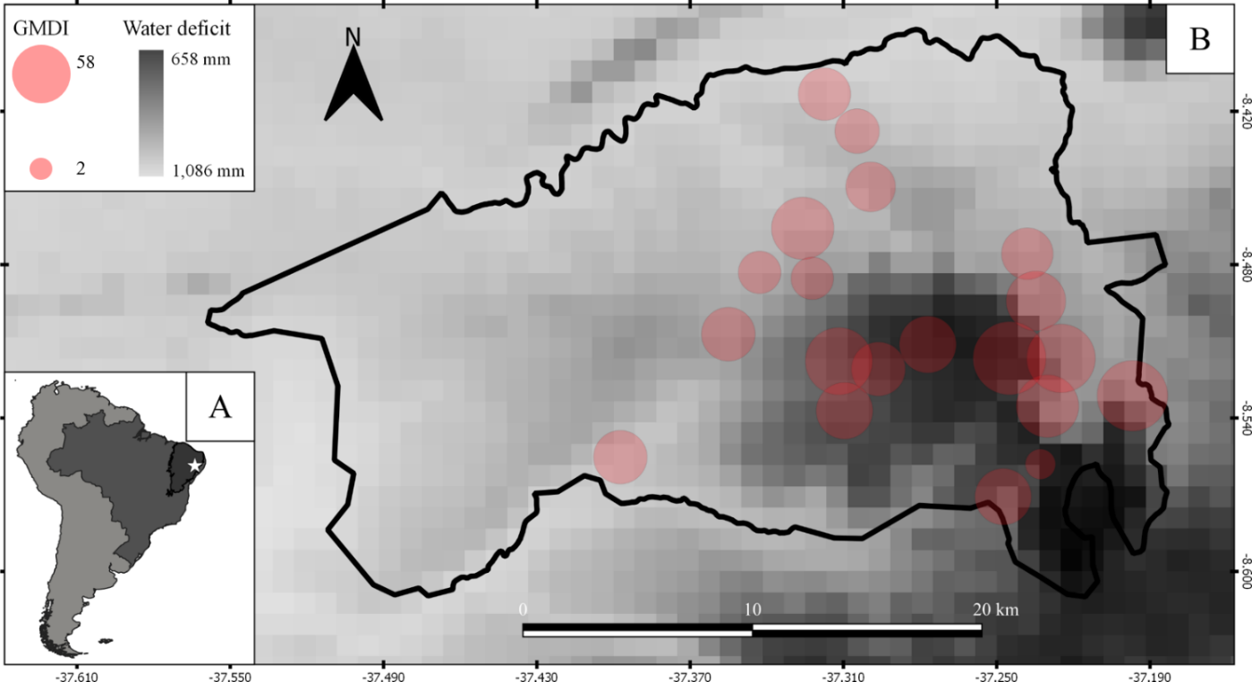
Figure S2. Plot distribution of (A) Dinoponera quadriceps, (B) Ectatomma muticum, (C) Dorymyrmex goeldii and (D) Pheidole radoskowskii along the disturbance and aridity gradients in the Catimbau National Park, north-eastern Brazil.

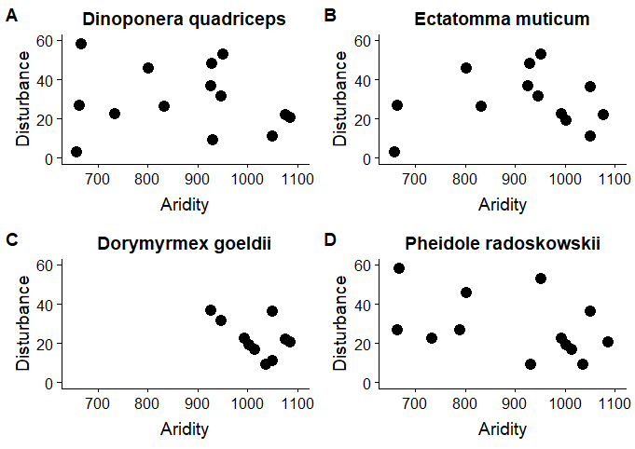

Figure S3. Corplot showing Pearson correlation coefficients of all traits across all individuals of (A) Dinoponera quadriceps, (B) Ectatomma muticum, (C) Dorymyrmex goeldii and (D) Pheidole radoskowskii measured along the aridity and disturbance gradients in the Catimbau National Park, north-eastern Brazil. Positive correlations are displayed in blue and negative correlations in red, color intensity is proportional to the correlation coefficients. Crosses represent no significant correlations (p-value > 0.05). CL = ratio of clypeus length to mesosoma length, ML = ratio of mandible length to mesosoma length, WL = mesosoma or Weber’s length, IOW = ratio of inter-ocular width to mesosoma length, EL = ratio of eye length to mesosoma length, P = count of hairs crossing mesosoma profile, LEG = ratio of leg length (combined length of femur and tibia) to mesosoma length and AL = ratio of antenna (combined funicle and scape) length to mesosoma length.
